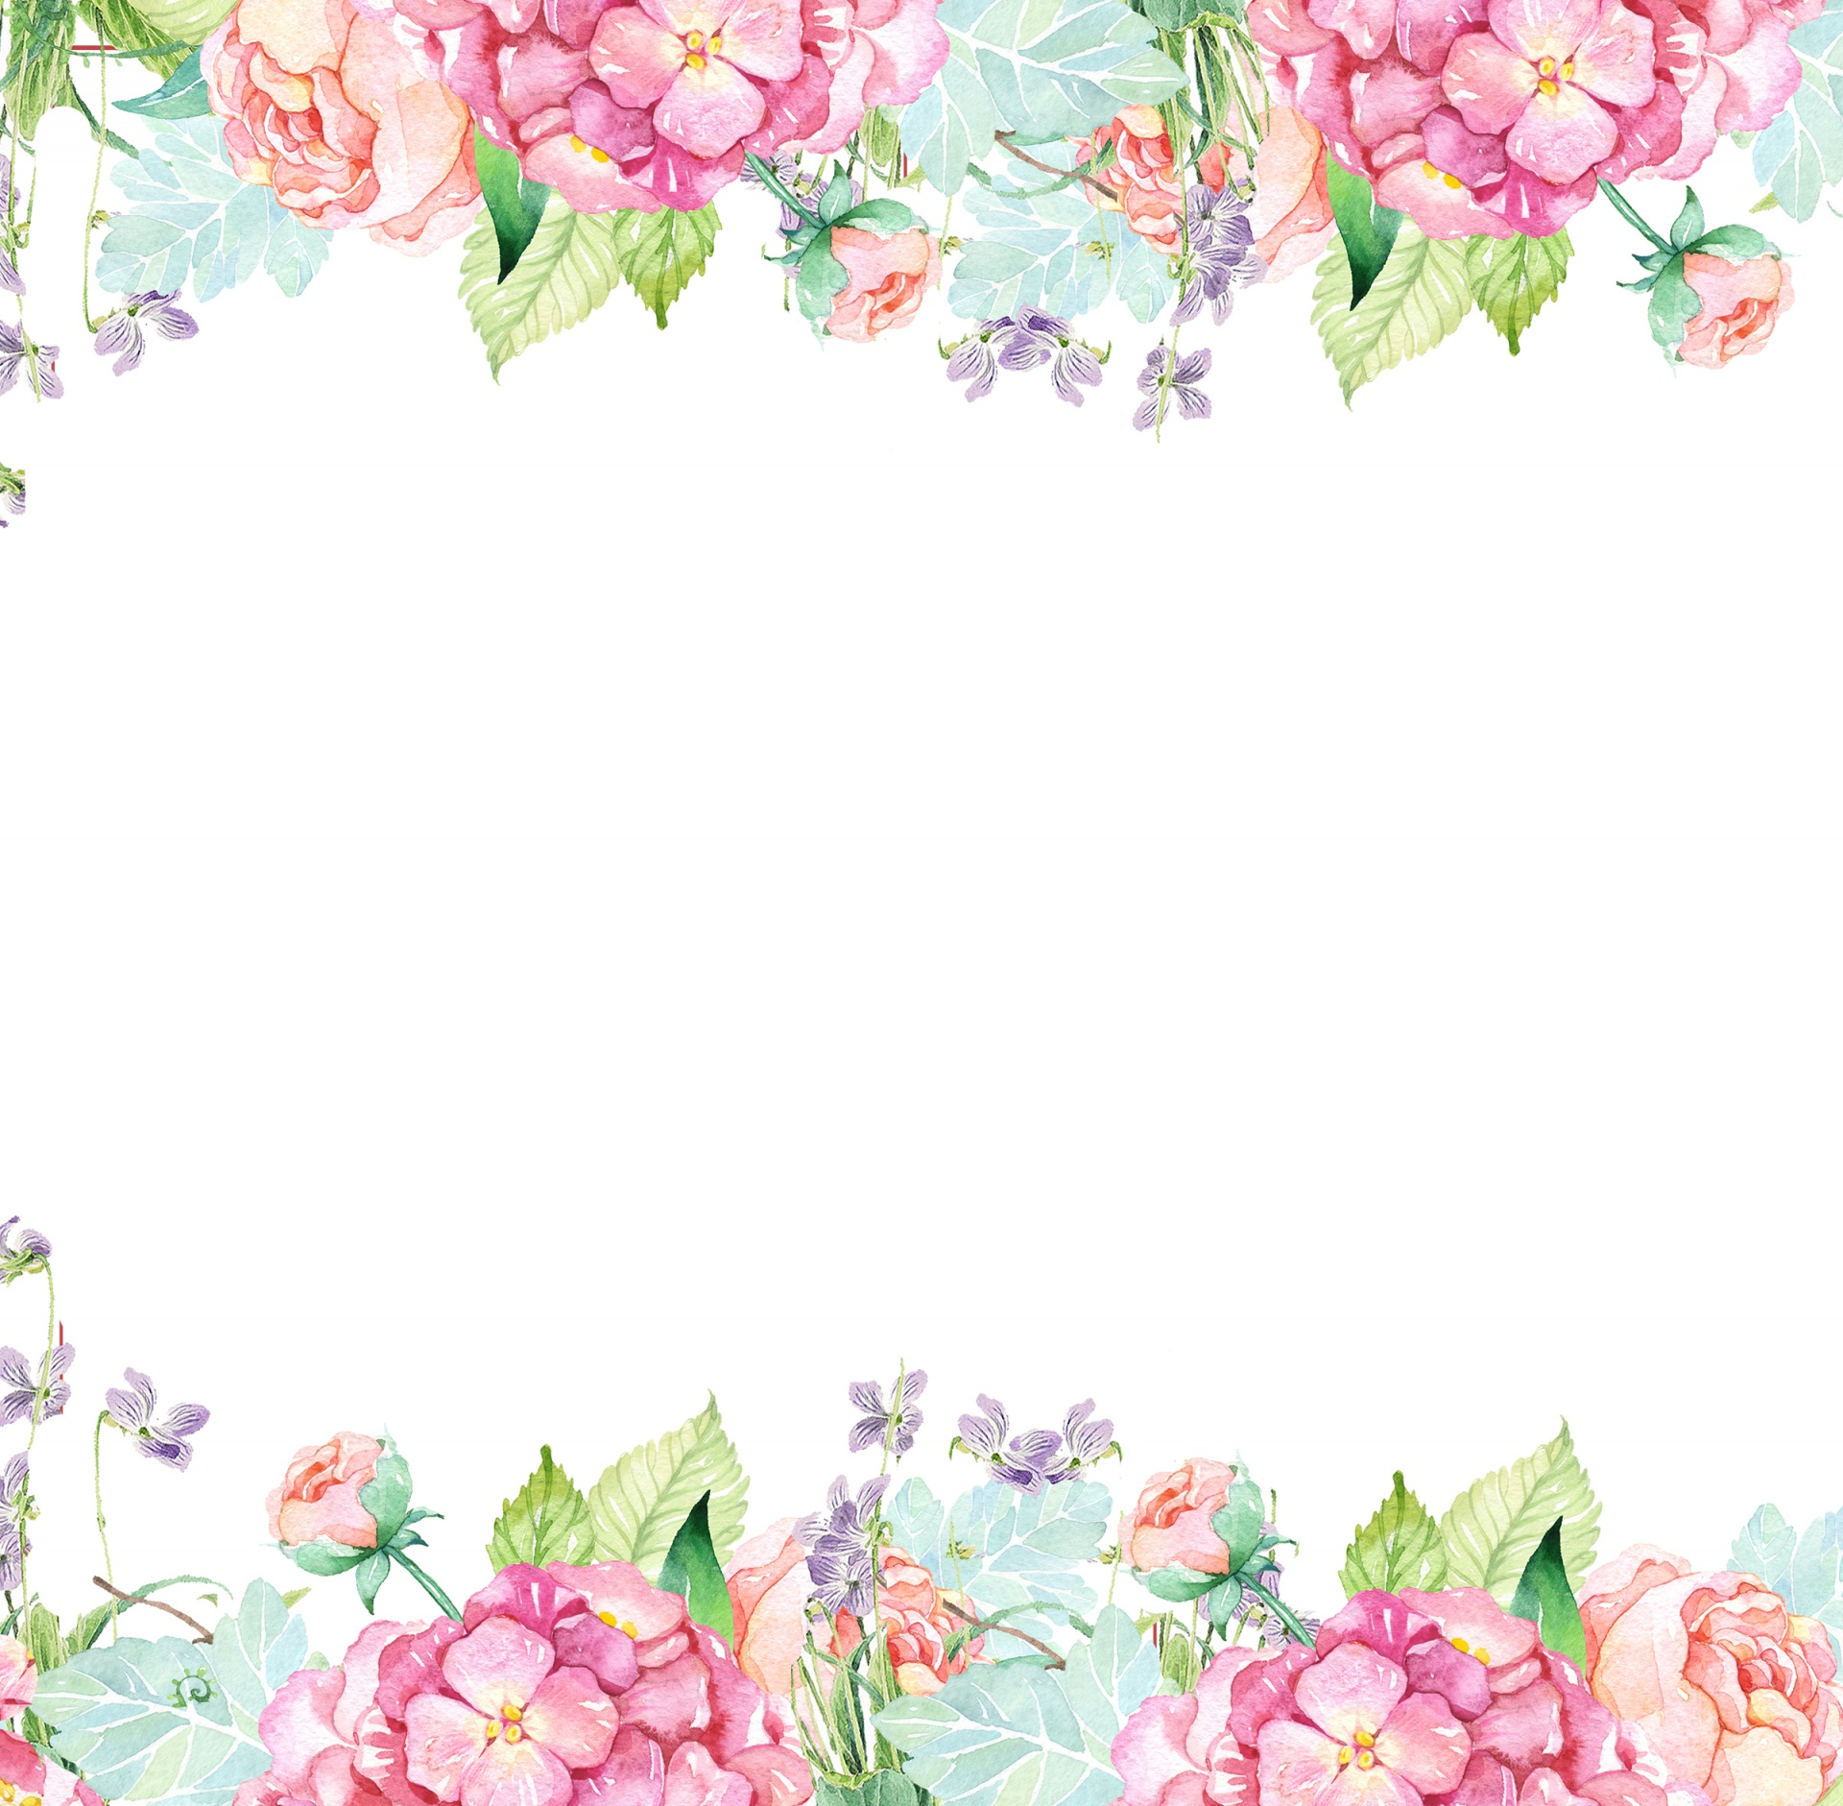

Name: Jenna Wilson Initals: JFW

Birthday: March 29

Preferred t-shirt size? Small

What is your favorite color? Yellow

What is your favorite flower/plant? Peonies

Where are your favorite places to shop? Free People, Anthropologie, Marshalls, and TJMaxx

What are your favorite restaurants? Surcheros, Cava, Midtown Caboose, and El Cocinero

What do you collect (candles, foxes, etc.)? Records

What is your favorite cold drink? Olipop sodas

What is your favorite hot drink? Vanilla lattes

What is your favorite sweet treat? Tru Fru frozen fruit and anything chocolate peanut butter

What is your favorite salty treat? Salt and vinegar potato chips and carrots with roasted red pepper hummus

What is your favorite fruit? Raspberries

Do you have any food allergies? None

Interests: traveling, concerts, and hiking

UMOJA House: Valor

Wish list for your classroom? <https://www.amazon.com/hz/wishlist/ls/1PSIJX3M2D8LP?ref_=wl_share>